**LAB PROJECT REPORT**



**CE-409L: Simulation and Modeling**

**Bank Management System**

**SECTION: B**

**Roll No:** 2021F-BCE-199, **Name:** Muhammad Khalil Ashraf

**Roll No:** 2021F-BCE-065, **Name:** Inshara Ahmed

**Roll No:** 2021F-BCE-059, **Name:** Rija Javed

**Roll No:** 2021F-BCE-244, **Name:** Muhammad Huzaifa

Department of Computer Engineering

Sir Syed University of Engineering & Technology

Karachi Pakistan.

**Course Instructor:** Engr. Safina Parveen

|  |  |
| --- | --- |
|  |  |

**OBJECTIVE:**

The objective of this project is to simulate a bank management system using Arena to analyze and optimize customer flow through various banking services such as account opening, ATM usage, deposits, and billing. It aims to evaluate queue performance, resource utilization, and total customer exit efficiency through a centralized routing and dispose mechanism.

**Description of the Project:**

This project models and simulates a comprehensive **Bank Management System** using **Arena Simulation Software**. The simulation represents the flow of customers entering a bank and routing them through one of four key services: **Account Opening**, **ATM Transactions**, **Deposits**, and **Billing**. Upon arrival, each customer is assigned a specific service type based on predefined probabilities using the DISC function. A single **Decide module** routes customers based on this classification, ensuring each follows the appropriate service path. Each service area is equipped with resources (staff or machines), and customers queue when the resource is busy, allowing for queue behavior and resource utilization analysis. After completing their transactions, customers are routed to a central **Exit Station**, from which they are disposed of through a unified exit point. This modular approach enables effective tracking of customer flow, queue times, and resource efficiency. The simulation helps identify service bottlenecks and provides insights into optimizing bank operations to improve overall customer satisfaction and reduce wait times.

**Software Required:**

* Arena Simulation

**Methodology:**

The simulation model of the **Bank Management System** was built using **Arena Simulation Software**, focusing on replicating the customer service flow and queue behavior within a bank. The methodology follows a modular approach, with each component representing a real-world activity in a bank. Here's how the model was constructed step by step:

**1. Create Module**

* **Purpose**: To generate incoming customer entities at specified intervals.
* **Configuration**:
  + **Entities per Arrival**: 1
  + **First Creation**: 0 minutes
  + **Time Between Arrivals**: Random distribution (e.g., EXPO(5))
* **Represents**: Customers entering the bank randomly over time.

**2. Assign Module**

* **Purpose**: To assign a type to each customer based on banking needs.
* **Configuration**:
  + **Attribute Assigned**: Customer.Type
  + **Value Assigned**: DISC(0.25,1, 0.5,2, 0.75,3, 1,4)
* **Represents**: Assigning customer service type:
  + 1 = Account Opening
  + 2 = ATM
  + 3 = Deposit
  + 4 = Billing

**3. Decide Module (N-Way by Condition)**

* **Purpose**: To route customers to the correct service based on their type.
* **Configuration**: N-Way by Condition with 4 conditions:
  + Customer.Type == 1 → Account Opening
  + Customer.Type == 2 → ATM
  + Customer.Type == 3 → Deposit
  + Customer.Type == 4 → Billing
* **Represents**: Decision-making process at the bank reception.

**4. Process Module**

* **Purpose**: To simulate service delivery with queueing and resource handling.
* **Configuration for each service**:
  + **Action**: Seize Delay Release
  + **Resource**:
    - AccountOfficer for Account Opening
    - ATM_Machine for ATM
    - DepositClerk for Deposit
    - BillingOfficer for Billing
  + **Delay**:
    - Account Opening: TRIA(3,5,7)
    - ATM: TRIA(1,2,3)
    - Deposit: UNIF(2,5)
    - Billing: TRIA(2,4,6)
* **Represents**: Actual banking operations and service time.

**5. Record Module**

* **Purpose**: To track metrics like number of customers served or time in queue.
* **Configuration**:
  + Type: Count or Time in Queue
  + Examples:
    - Record Aco Count, Record ATM Time in Queue
* **Represents**: Data collection for performance evaluation.

**6. Route Module**

* **Purpose**: To transport customers to a centralized exit.
* **Configuration**:
  + **Destination Type**: Station
  + **Destination**: Exit Station
* **Represents**: Customer leaving the service point and walking out.

**7. Station Module**

* **Purpose**: Acts as a central exit point for all service paths.
* **Configuration**: Single station named Exit Station
* **Represents**: Exit hall of the bank.

**8. Dispose Module**

* **Purpose**: To remove entities from the system.
* **Configuration**: Single module named Exit Bank
* **Represents**: Customers exiting the bank.

**Diagram:**

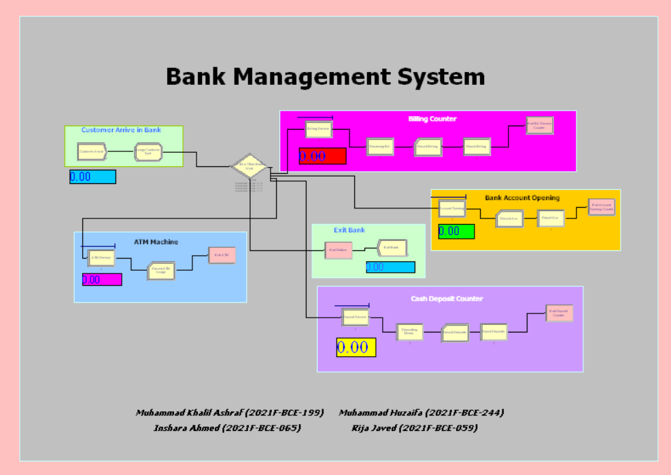

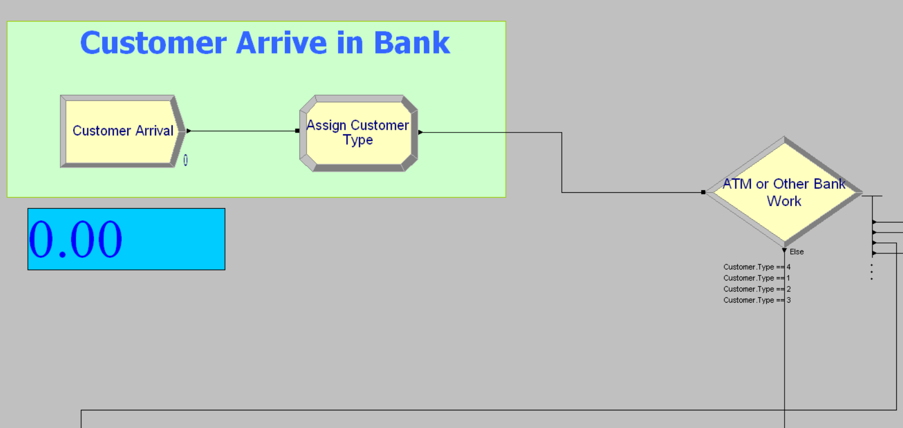

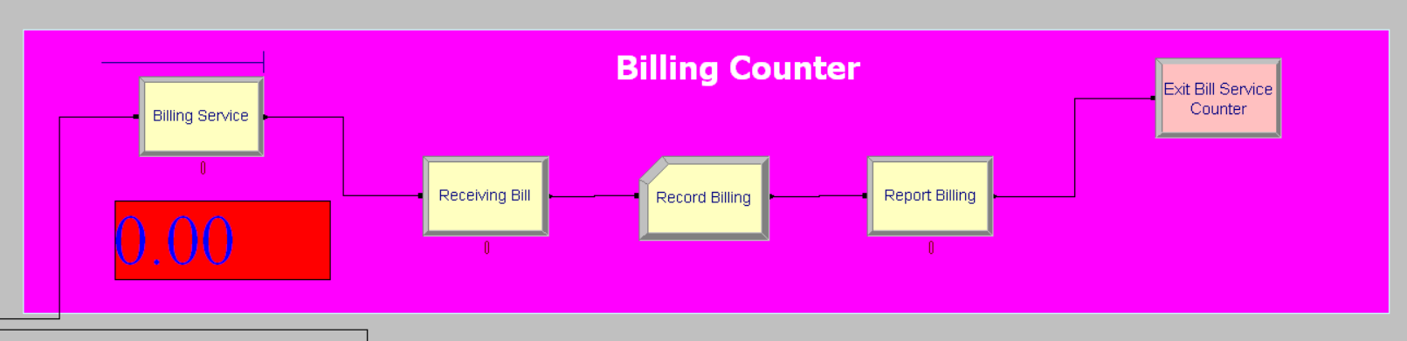

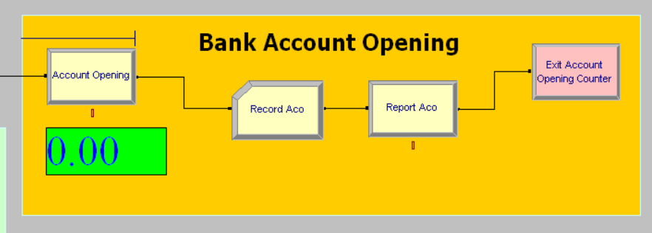

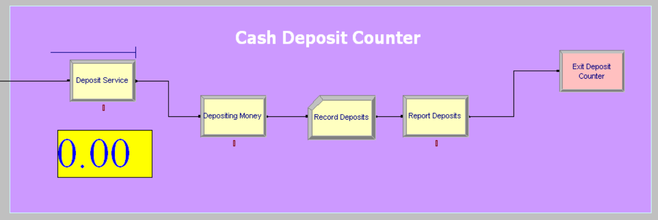

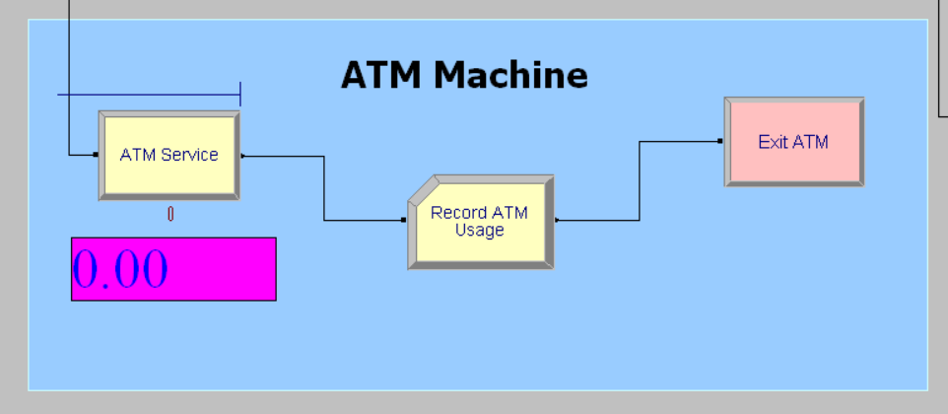

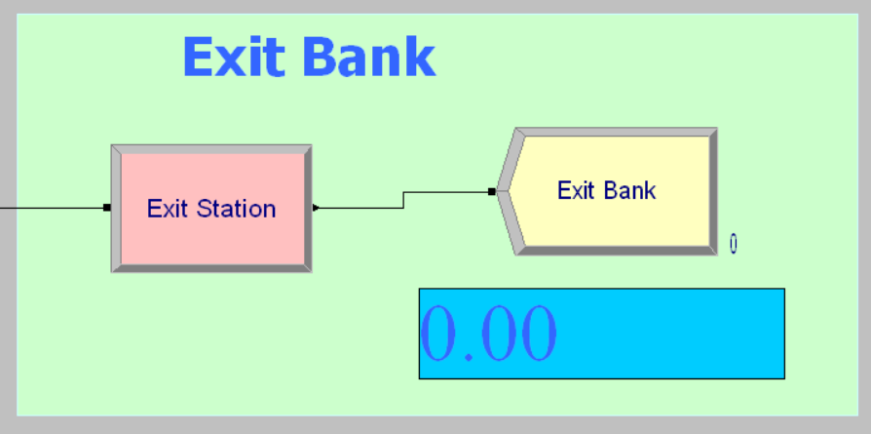

**Data Modules:**

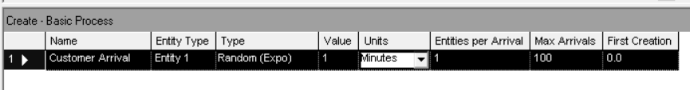

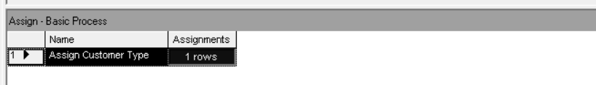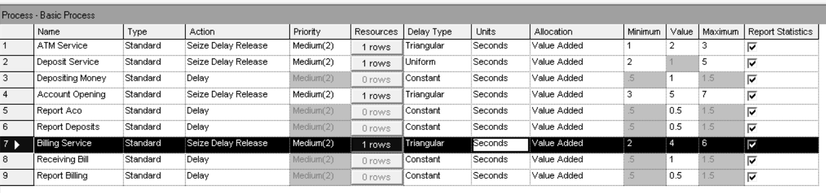

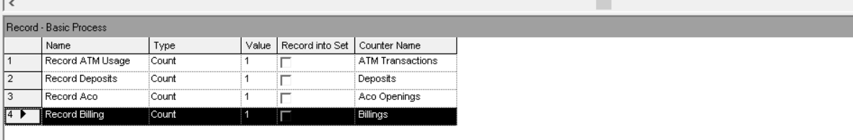

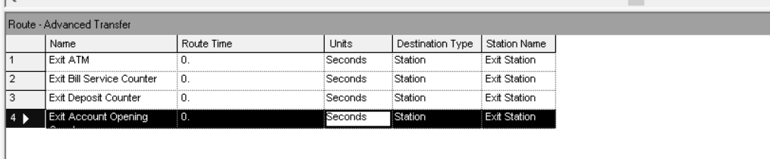

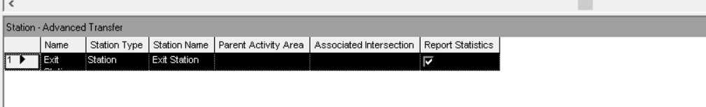

**Observation:**

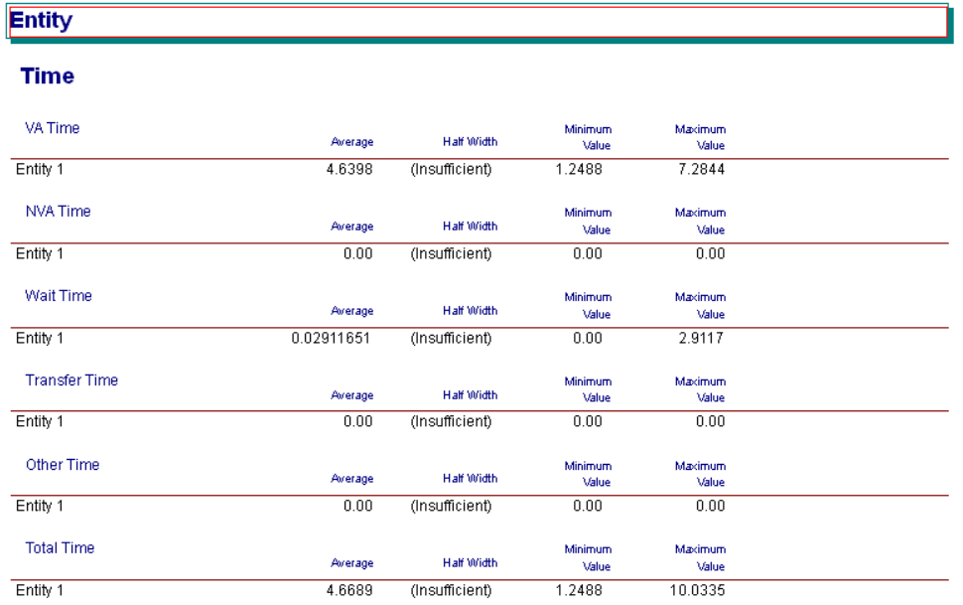

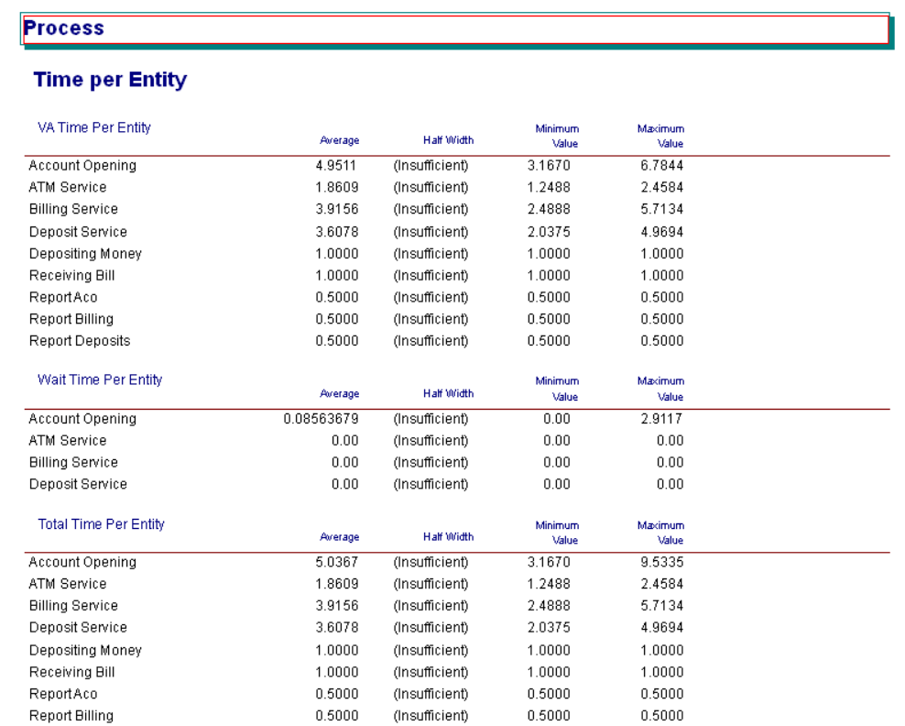

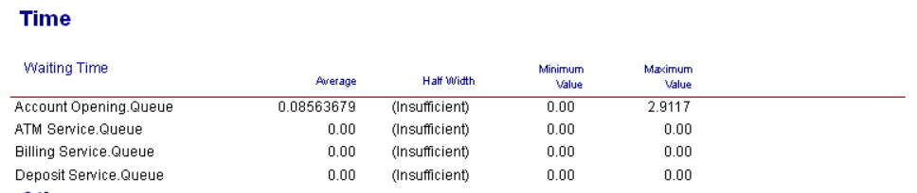

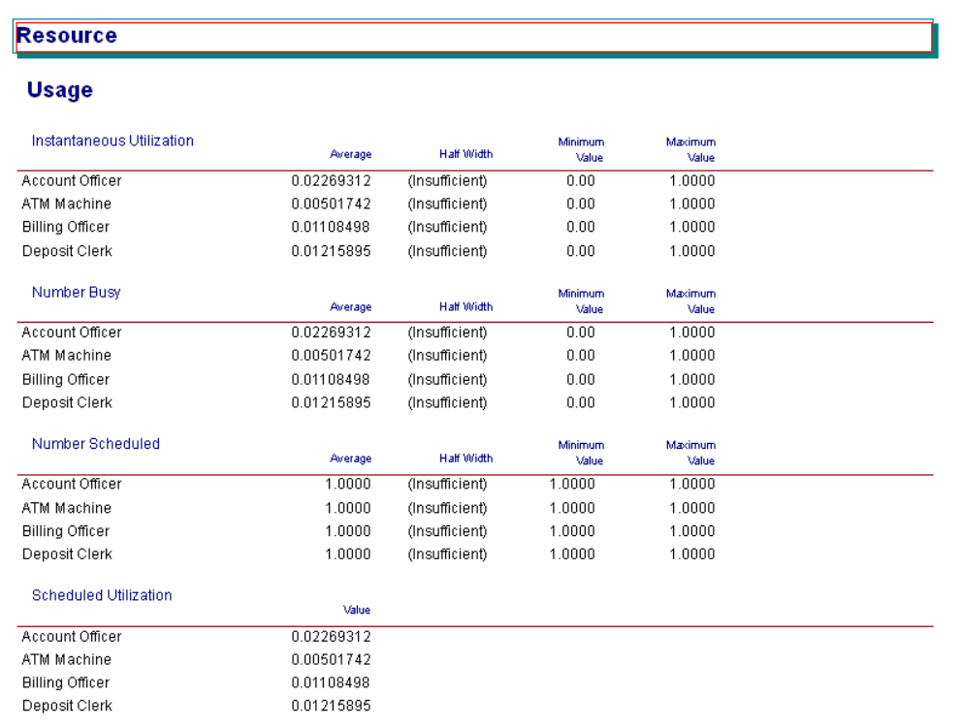

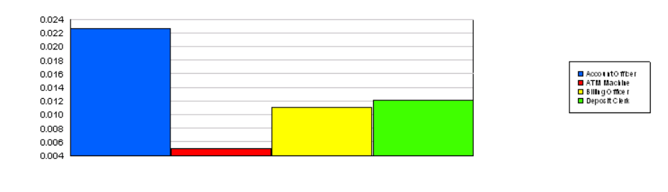

**Result & Discussion:**

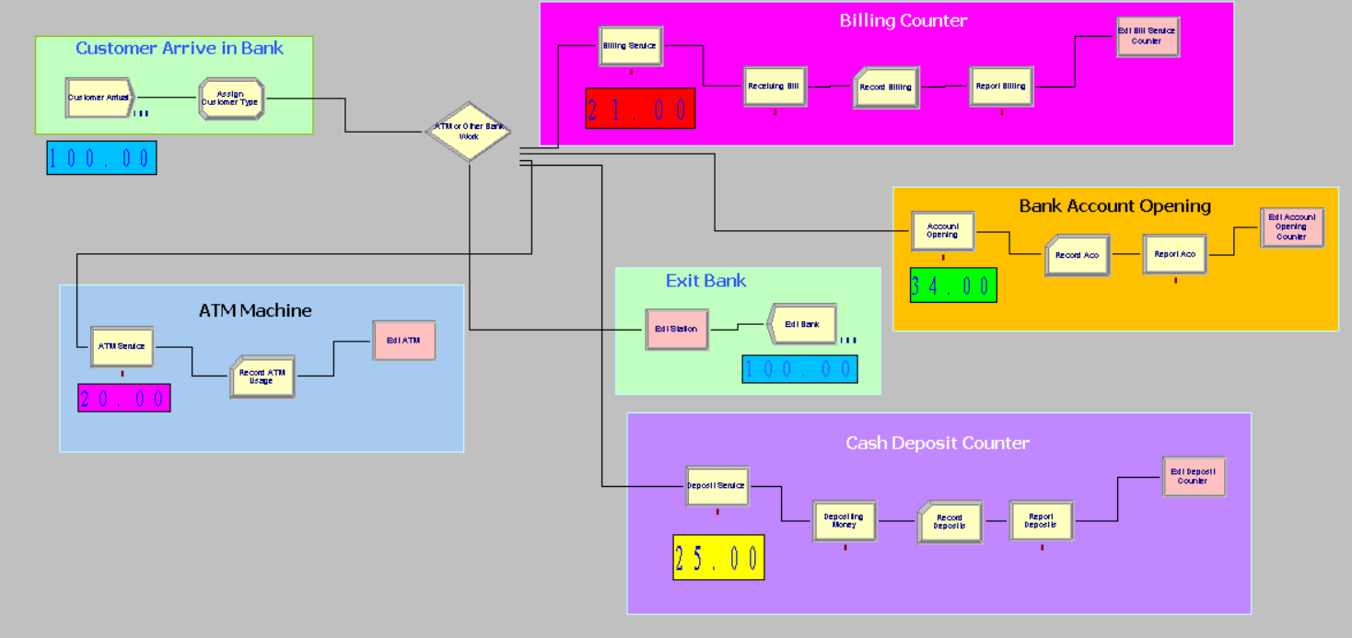

The simulation of the Bank Management System provided valuable insights into customer flow, queue behavior, and resource utilization across various banking services. The results showed that the **ATM service**, with its relatively shorter service time, had higher customer throughput and shorter queues, while **Account Opening and Billing counters** experienced longer wait times due to higher service durations and limited resource availability. The centralized **Route-to-Station-to-Dispose** structure allowed consistent tracking of total customer exits, confirming the logical flow of entities through the system. Queue statistics indicated that **Deposit and Billing services** required better resource allocation to reduce bottlenecks. Overall, the simulation validated that optimized staff distribution and queue balancing can significantly improve customer service efficiency and reduce average waiting times in a real-world banking environment.

**Conclusion:**

The simulation of the Bank Management System using Arena successfully modeled the dynamic behavior of customer service operations within a bank environment. By representing key processes such as account opening, ATM usage, deposits, and billing through discrete event simulation, the project provided meaningful insights into queue lengths, service times, and resource utilization. The use of a centralized routing and exit mechanism enhanced clarity in tracking customer flow and system performance. The results demonstrated that service efficiency can be significantly improved by optimizing resource allocation and minimizing customer wait times. Overall, the simulation serves as an effective decision-support tool for evaluating and improving operational strategies in banking systems.